Trip to Michigan
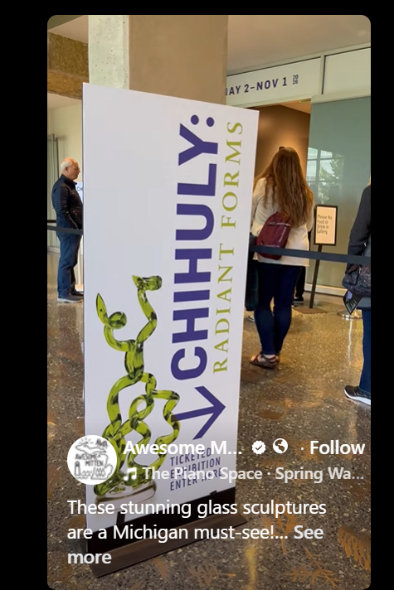
Monday 9/14—Pick up Budget rental car 7PM
-------------------------------------------------------------------------------------------------------------------------
Tuesday 9/15—leave early AM
Stop 1- Grand Rapids (3 hrs 18)
- Brunch/Lunch possibilities: Tupelo Honey, Schnitz’s deli, Blue Dog Tavern (burgers), Social Misfits (waffles)
- Meyer May House (Frank Lloyd Wright)--a drive-by
- Chihuly at Meijer Gardens
- Neighborhood Drive thru:
Black Hills: affordability, Black Hills is ranked as the cheapest neighborhood to live in Grand Rapids for 2025.
Cherry Run: affordable option, Cherry Run is also recognized for its cost-effectiveness.
Garfield Park: balance of affordability and community feel.
Westside Connection: popular choice for its mix of residential and commercial areas.
Fuller Avenue: affordable housing options.
Roosevelt Park: quieter atmosphere with affordable living.
Alger Heights: welcoming neighborhood with a strong community feel.
Fulton Heights: affordable option with good community amenities.
Highland Park: tree-lined streets and a residential atmosphere.
Eastgate: proximity to downtown and affordable housing.
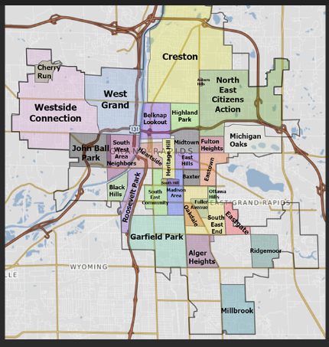

Stop 2—Ludington (1 hr 45)
SLEEP HERE: Summer’s Inn, 717 Ludington Ave, Ludington MI 494431 Ph. 231/843.3448 $155

- North Breakwater Lighthouse (#1 lighthouse in MI-- closed M-W) 22 min walk
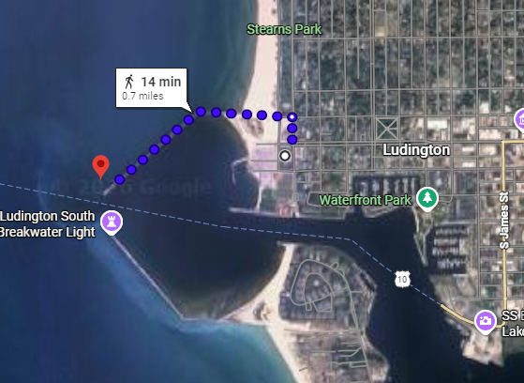
Big Sable Point Lighthouse (if we have time for this…sadly closed M-W, 1.5 mi hike from parking lot)
TRY: White Pine Village, Port Museum, Check out dock
https://westmichiganguides.com/west-michigan-lighthouses
https://historicwhitepinevillage.org/ (this may be closed by the time we arrive)
------------------------------------------------------------------------------------------------------------------
Wednesday 9/16
Stop 1—Sleeping Bear Dunes (2 hrs) NEED PASS per car $25 https://www.recreation.gov/sitepass/74294
For less than 3 hour visit:
-Take a drive on the 7-mile Pierce Stocking Scenic Drive
-Trek up the Dune Climb - or sit back and watch the rest of your party climb
-Explore Glen Haven and the Maritime Museum
-Dip your toes in the tranquil Loon Lake

Stop 2—Traverse City (38 mins)
SLEEP HERE: Brio Beach Inn, 1465 US 31 N, Traverse City, MI 49686 Ph 231/946.6930, $245 approx
-Wineries, distilleries, city trail, tour town, lighthouse, eat well
------------------------------------------------------------------------------------------------------------------
Thursday 9/17
Stop 1—Charlevoix (1 hr)
-Take a drive around the lake…Tour Town of Alden?
Petosky stones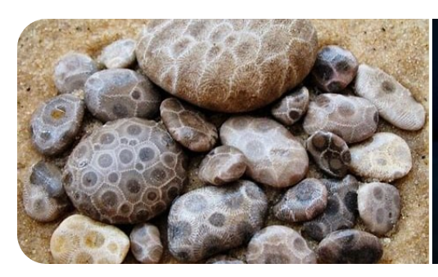

petoo
-Clear-bottom kayaks or do a boat ride down the lake
-Petosky stone search , choose one:
Bryant Park Beach--1097 Peninsula Dr, Traverse City, MI 49686
Van’s Beach--205 Cedar St, Leland, MI 49654
Peterson Park--10001 E Peterson Park Rd, Northport, MI 49670
Magnus Park--901 West Lake St, Petoskey, MI 49770
Cross Village Beach--100 Park Ln, Harbor Springs, MI 49740

Stop 2—Mackinaw City (1 hr 10) This is just a place to base ourselves to go to Mackinac Island
SLEEP HERE 2 nights: Lighthouse View Hotel, 699 N Huron Ave, Mackinaw City, MI 49701 Ph 231/436.5304 $298
------------------------------------------------------------------------------------------------------------------
Friday 9/18
All Day--Mackinac Island—7:00 AM Park at the Ferry dock -OR call shuttle and it will pick us up if we are staying within a 1.5 mile radius of the ferry dock. If driving to ferry, arrive ½ hr prior to departure (7:30 AM).
- Shepler’s Ferry info 800.638.9892, $10 parking, $39 ea. Tickets purchased
- Lucky Bean Coffee House 7383 Market St, Mackinac Island, MI 49757 7AM
- Mackinac Island Bike Shop 7421 Main St, $18/hr (906) 847-6337 8 AM to 7 PM

------------------------------------------------------------------------------------------------------------------
Saturday 9/19
Stop 1—Frankenmuth (2 hrs 50)
-Little Bavaria, cute, quaint, good food?
Stop 2—Optional: Midland, Saginaw, Flint (1 hr-1 hr 30)
CANADA DRIVE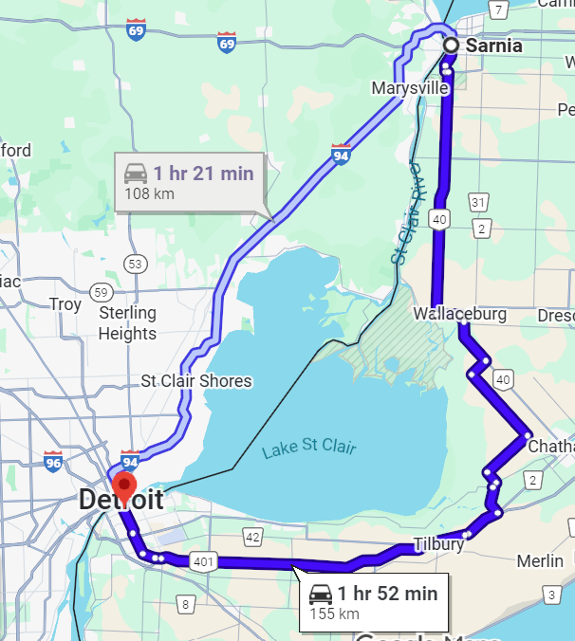
Small livable towns (Howell, “best overall downtown”!)
Stop 3—Sarnia CANADA (2 hrs to border)
Waterfront Trail (just north of hotel)

SLEEP HERE: Sheraton Four Points 1498 Venetian Boulevard Pt Edward, Ph 519.336.4130 $169 Canadian
---------------------------------------------------------------------------
Sunday 9/20
Stop 1— Stones and Bones Museum 223 Christina St N, 11AM-5PM (last entry 4PM)
Stop 2--Windsor CANADA (2 hrs to border) Follow M1 to take the Tunnel
Stop 3—Detroit
Bell Isle Aquarium
Henry Ford Museum
The Belt (meet Emma there?)
Stop 4—Belleville, MI
SLEEP JULIA’S
OR
SLEEP at Hampton Inn Detroit/Belleville, 46280 N I-94 Service Dr, Bellville, MI 48111 Ph 734/699.2424, $267
------------------------------------------------------------------------------------------------------------------
9/21
Stop 1—Ann Arbor?
Stop 2—Kalamazoo (1 hr 46)
To take a driving break?
Stop 3—Home (3 hrs)

NOTABLES>>>
***BRING PASSPORT AND SLEEP AIDS (earplugs, gummies…)***
RENTAL CAR: Canada: Vehicles may be driven into Canada with no restrictions. The rental counter must be notified at the time of the rental that you plan to drive into Canada so the location can provide a copy of the "Canadian Non-Resident Insurance Card" or you may download the card www.avis.ca/content/dam/avis/na/ca/common/pdf-files/abg__canada_non_resident_card.pdf (provided at no cost). Based on availability, one-way rentals may be allowed to some Canada cities.
One additional driver fee will be waived for Costco members at participating locations. Age restrictions and renter requirements may apply.

KNOWN EXPENSES
Car rental $368—MINE!
Hotels
Ludington $155
Traverse City $245
Mackinaw City $298 (2 nights)
Sarnia $125 (US dollars, per exchange rate)
Belleville $267 (This may not happen)
Entry fee to Sleeping Bear $25—MINE!
Ferry to Mackinac $41 ea (already purchased)
Bike rental Mackinac $18 ea

OTHER EXPENSES
Food
Gas—MINE!
???

